**Practical – 1**

AIM

Write a program in C to find an element in array using linear search.

INPUT

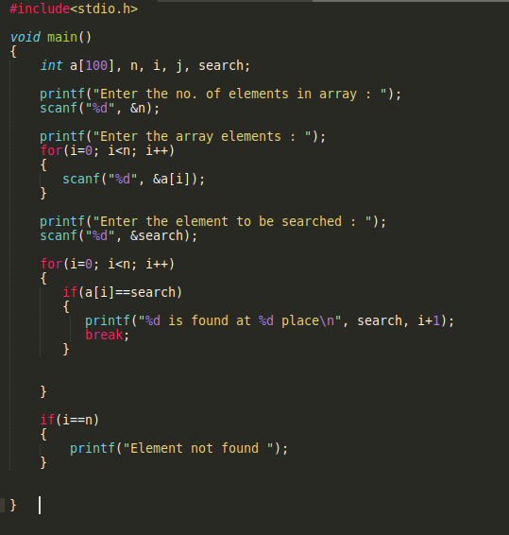

OUTPUT

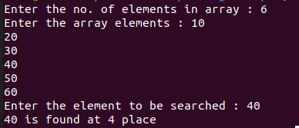

**Practical – 2**

AIM

Write a program in C to find an element in an array using binary search.

INPUT

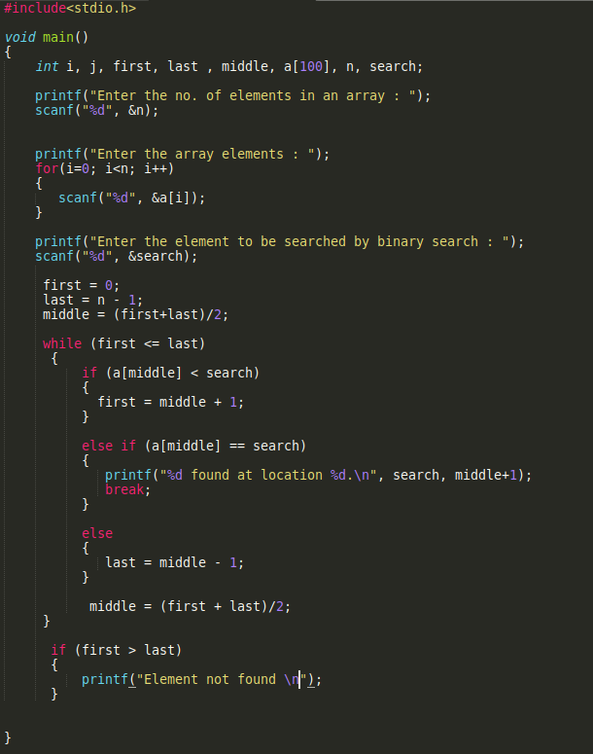

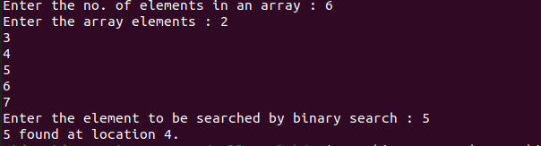OUTPUT

**Practical – 3**

AIM

Write a program in C to sort the elements in an array using Insertion Sort.

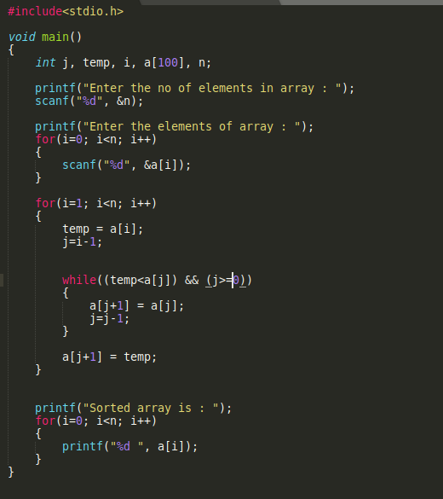INPUT

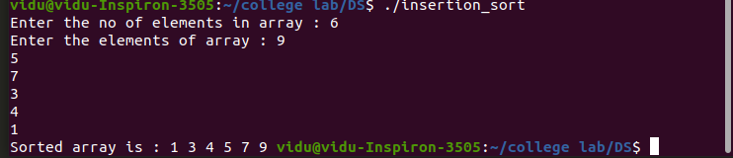OUTPUT

**Practical – 4**

AIM

Write a program in C to sort the elements in an array using Selection Sort.

INPUT

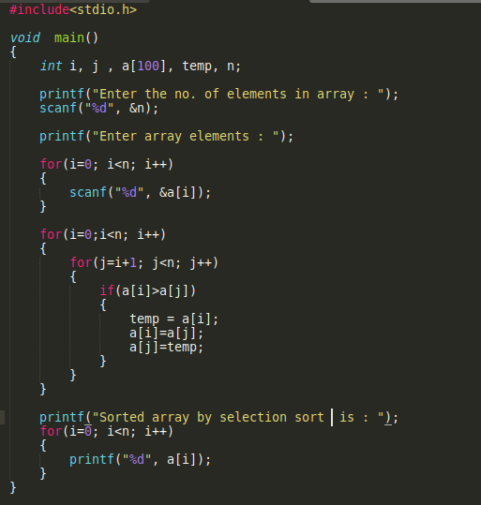

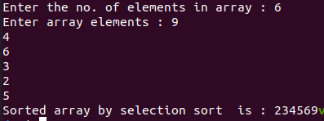OUTPUT